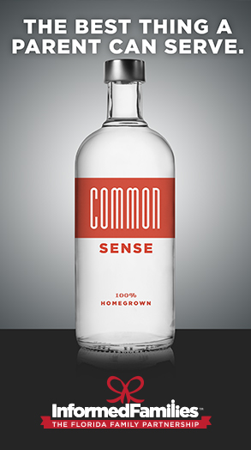
The average age at which children begin drinking is 13 (CAMY, 2014). Young people who begin drinking before age 15
are five times more likely to develop alcohol dependence
than those who begin drinking at age 21. (CAMY 2014)

WILL YOU HELP TO CHANGE THESE STASTISTICS?

Safe Homes Safe Parties Campaign® An initiative developed by Informed Families/The Florida Family Partnership and implemented by parents of teens and pre-teens to ensure that drugs, alcohol and cigarettes will not be permitted at parties held in their homes and discouraged at parties in the community.

Parents take ownership of the program by signing a pledge that states that they will:
- Set guidelines.
- Not allow underage youth to drink alcoholic beverages or use tobacco or drugs in their home or places of business.
- Be present at all pre-teen and teenage parties held in their homes to ensure that no drugs, alcohol or tobacco are present.
- Encourage future drug and alcohol - free activities for underage youth.

Parents’ Guide to Teen Parties

There are many pressures drawing youth to the use of cigarettes, alcohol and other harmful drugs. The strongest pressures on the young adults are social/societal (including advertising & media) and the need for group acceptance. Many parents and their teenagers talk about appropriate guidelines in this area, yet continue to feel helpless. Some parents, wanting their teenagers to belong to a group, serve alcohol at parties to their teenagers and friends. When parents work together, the pressure to serve or allow the use of illegal beverages, tobacco and other drugs will be significantly reduced. Don’t fall prey to the teen tactic, “But all the other parents let their kids do it.” Review the following guidelines and discuss them with your family and friends. Communicate what standards you expect to be followed. Support one another within families and from family to family.

Communication and honesty are important to keep your teen safe. Teens whose parents talk with them regularly about drugs and alcohol are 42% less likely to use substances than those whose parents don't. Tell your teens that you expect them not to use alcohol or other drugs at parties.
Parent networking is the best prevention tool to combat underage drinking. Get to know your teen's friends and their parents. If your teen is planning on going to a party, call the parents to ensure that they will be home and that they will not allow drugs or alcohol. If this is not possible, don't let your teen go.
Parents are legally responsible for anything that happens to a minor who has been served alcohol or other drugs in their home. If anyone brings alcohol or other drugs to your home, be prepared to contact their parents. And if someone comes to your home already intoxicated, make sure that they get home safely. Help your teen feel responsible for this as well.

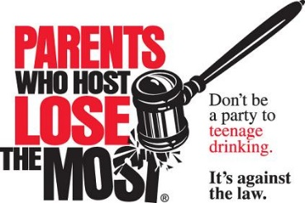
Parents may be criminally or civilly liable if...
- Alcohol is provided to a minor at a party they have organized.
- Someone's property is damaged.
- Someone is injured.
- Someone leaves and gets into a car accident and/or injures someone else.
- Someone dies.

If you are hosting a teen party...
- Plan in Advance. Go over party plans with your teen. Encourage your teen to plan non-alcohol-related group activities or games.
- Keep parties small. Ten to 15 teens for each adult. Make sure at least one adult is present at all times. Ask other parents to come over to help you if you need it.
- Set a guest list. The party should be for invited guests only. No "crashers" allowed. This will help avoid the "open party" situation.
- Set starting and ending times for the party. Check local curfew laws to determine an ending time.
- Set party "rules" and your expectations. Discuss them with your teen before the party. Rules should include the following:
  - No tobacco, alcohol, or other drugs.
  - No one can leave the party and then return.
  - Lights are left on at all times.
  - Certain rooms of the house are off-limits.
- Have plenty of food and non-alcoholic beverages available. Also, put your alcohol and any prescription or over-the-counter medicines in a locked cabinet.
- Be there, but not square. Pick out a spot where you can see what is going on without being in the way. You can also help serve snacks and beverages.

If your teen is going to a party...
- Know where your teen is going and how long he will be there. Have the phone number and address of the party. Ask your teen to call you if the location of the party changes. Be sure to let your teen know where you will be during the party.
- Call the parent of the party host to make sure a parent will be home the entire time and supervising the party. Make sure that tobacco, alcohol, and other drugs will not be allowed.
- Talk with your teen beforehand about how to handle a situation where alcohol is available at a party.
- Make sure your teen has a way to get to and from the party. Make it easy for your teen to leave a party by making it clear that he can call at any time for a ride home. Discuss why he might need to make such a call. Remind your teen NEVER to ride home with a driver who has been drinking or using other drugs.
- Be up to greet your teen when he comes home. This can be a good way to check the time and talk about the evening.
- If your teen is staying overnight at a friend's house after the party, verify this arrangement with the friend's parents and that they will be home.
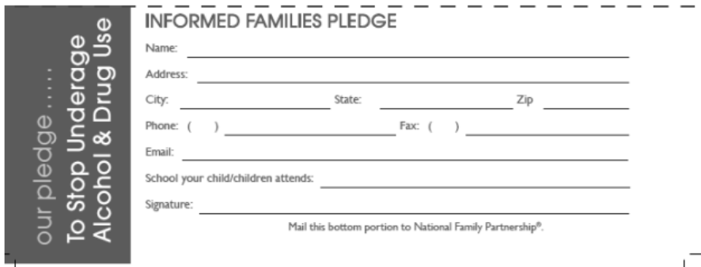
Please complete online (http://informedfamilies.org/campaigns/safe_home/pledge/):

Dell Rapids School District and Dell Rapids St. Mary’s
Red Ribbon Celebration October 27-31, 2014
"INOK" - It's Not Okay" to use Drugs!
A Healthy Me is A Drug Free Me!

